ASSIGNMENT
URBAN COMPANY
AIM :
To develop a responsive web page for a home services platform like Urban Company with basic service viewing and booking features.
PROGRAM :
<!DOCTYPE html>
<html>
<head>
<title>Urban Company</title>
<!-- BOOTSTRAP CDN -->
<link href="https://cdn.jsdelivr.net/npm/bootstrap@5.3.0/dist/css/bootstrap.min.css" rel="stylesheet">
<style>
body {
background: #f6f7f9;
}
/* HOVER */
.card-hover:hover {
background: #eee;
cursor: pointer;
transform: scale(1.03);
transition: 0.2s;
}
.details {
display: none;
}
/* SERVICE ICON IMAGE */
.service-img {
height: 80px;
width: 100px;
object-fit: cover;
border-radius: 8px;
}
.main-img {
height: 200px;
object-fit: cover;
}
.social-btn {
width: 50px;
height: 50px;
border-radius: 50%;
background: #eee;
display: inline-flex;
align-items: center;
justify-content: center;
font-size: 20px;
}
</style>
</head>
<body>
<!-- HEADER -->
<nav class="navbar bg-white shadow-sm px-4">
<span class="navbar-brand fw-bold">Urban Company</span>
<input class="form-control w-25" placeholder="Search for AC service">
</nav>
<div class="container my-5">
<div class="row">
<!-- LEFT -->
<div class="col-md-5">
<h1>Home services at your doorstep</h1>
<!-- SERVICES -->
<div class="bg-white p-3 rounded mt-4">
<div class="row g-3">
<!-- SALON -->
<div class="col-6">
<div class="p-3 text-center bg-light rounded card-hover" onclick="showService('Salon')">
<img src="https://i.pinimg.com/236x/19/84/17/198417e2863af2e1fe8ff902ee5f83b7.jpg" class="service-img mb-2">
<p>Salon at home for Women</p>
</div>
</div>
<!-- CLEANING -->
<div class="col-6">
<div class="p-3 text-center bg-light rounded card-hover" onclick="showService('Cleaning')">
<img src="https://img.freepik.com/premium-vector/vacuum-cleaner-clipart-cartoon-style-vector-illustration_761413-12610.jpg?w=1380" class="service-img mb-2">
<p>Bathroom & Kitchen Cleaning</p>
</div>
</div>
<!-- AC -->
<div class="col-6">
<div class="p-3 text-center bg-light rounded card-hover" onclick="showService('AC Repair')">
<img src="https://tse3.mm.bing.net/th/id/OIP.GYySM_RwyHZQ30AOQN_8swHaEn?w=680&h=424&rs=1&pid=ImgDetMain&o=7&rm=3" class="service-img mb-2">
<p>AC Service and Repair</p>
</div>
</div>
<!-- PLUMBER -->
<div class="col-6">
<div class="p-3 text-center bg-light rounded card-hover" onclick="showService('Plumber')">
<img src="https://img.freepik.com/premium-vector/pipe-fixing-icon-style_822882-326984.jpg" class="service-img mb-2">
<p>Plumbers</p>
</div>
</div>
</div>
</div>
<!-- DETAILS -->
<div id="detailsBox" class="details bg-white p-3 rounded mt-3">
<h3 id="title"></h3>
<p id="desc"></p>
<p><strong>Price:</strong> ₹<span id="price"></span></p>
<button class="btn btn-dark" onclick="bookNow()">Book Now</button>
</div>
<!-- STATS -->
<div class="d-flex gap-4 mt-3">
<div>⭐ 4.8 Rating</div>
<div>👥 12M+ Customers</div>
</div>
</div>
<!-- RIGHT -->
<div class="col-md-7">
<div class="row g-3">
<div class="col-6">
<img class="img-fluid rounded main-img" src="https://im.whatshot.in/img/2022/Jan/home-salon-cropped-1643278389.jpg">
</div>
<div class="col-6">
<img class="img-fluid rounded main-img" src="https://5.imimg.com/data5/SELLER/Default/2024/7/434060171/JK/VI/LY/225344471/bathroom-cleaning-services-500x500.jpeg">
</div>
<div class="col-6">
<img class="img-fluid rounded main-img" src="https://urbanappliancescare.com/wp-content/uploads/2024/02/split-ac-service-min-1024x576.webp">
</div>
<div class="col-6">
<img class="img-fluid rounded main-img" src="https://res.cloudinary.com/urbanclap/image/upload/q_auto,f_auto,fl_progressive:steep,w_532/t_high_res_category/images/growth/luminosity/1653891567347-044c93.jpeg">
</div>
</div>
</div>
</div>
</div>
<!-- FOOTER -->
<div class="bg-light p-5 mt-5">
<div class="row">
<div class="col-md-2 fw-bold">Urban Company</div>
<div class="col-md-2">
<h5>Company</h5>
<p>About us</p>
<p>Investor Relations</p>
<p>Terms & conditions</p>
<p>Privacy policy</p>
<p>Careers</p>
</div>
<div class="col-md-2">
<h5>For customers</h5>
<p>UC reviews</p>
<p>Categories near you</p>
<p>Contact us</p>
</div>
<div class="col-md-2">
<h5>For professionals</h5>
<p>Register as a professional</p>
</div>
<div class="col-md-4">
<h5>Social links</h5>
<button class="btn btn-dark m-1 social-btn">
<img src="https://tse2.mm.bing.net/th/id/OIP.H-JqP1tyu6zOqW3IoqLGoQHaHa?rs=1&pid=ImgDetMain&o=7&rm=3" style="width: 50px; height: 50px;">
</button>
<button class="btn btn-dark m-1 social-btn">
<img src="https://tse1.mm.bing.net/th/id/OIP.sXbQogNtxBsyeqMd7b-BtwAAAA?w=374&h=374&rs=1&pid=ImgDetMain&o=7&rm=3" style="width: 50px; height: 50px;">
</button>
<button class="btn btn-dark m-1 social-btn">
<img src="https://cloudpng.com/images/all_img/1751198923_instagram-logo-transparent-png.png" style="width: 50px; height: 50px;">
</button>
<button class="btn btn-dark m-1 social-btn">
<img src="https://tse4.mm.bing.net/th/id/OIP.kRiZCAs2PPjMXZQyNke-_QAAAA?rs=1&pid=ImgDetMain&o=7&rm=3" style="width: 50px; height: 50px;">
</button>
<button class="btn btn-dark m-1">Download on the App Store</button><br>
<button class="btn btn-dark m-1">Get it on Google Play</button>
</div>
<hr>
<p class="text-center text-muted">© Copyright 2026 Urban Company Limited. All rights reserved.</p>
</div>
<script>
const services = {
"Salon": {
title: "Salon at home for Women",
desc: "Facial, waxing, threading and full beauty services at home.",
price: 499
},
"Cleaning": {
title: "Bathroom & Kitchen Cleaning",
desc: "Deep cleaning of kitchen and bathroom services.",
price: 999
},
"AC Repair": {
title: "AC Service and Repair",
desc: "AC installation, repair and gas refill services.",
price: 599
},
"Plumber": {
title: "Plumbers",
desc: "Fix leaks, taps, pipelines and bathroom fittings.",
price: 299
}
};
let selectedService = "";
function showService(service) {
selectedService = service;
document.getElementById("detailsBox").style.display = "block";
document.getElementById("title").innerText = services[service].title;
document.getElementById("desc").innerText = services[service].desc;
document.getElementById("price").innerText = services[service].price;
}
function bookNow() {
alert("Booking confirmed for " + selectedService);
}
</script>
</body>
</html>
OUTPUT : 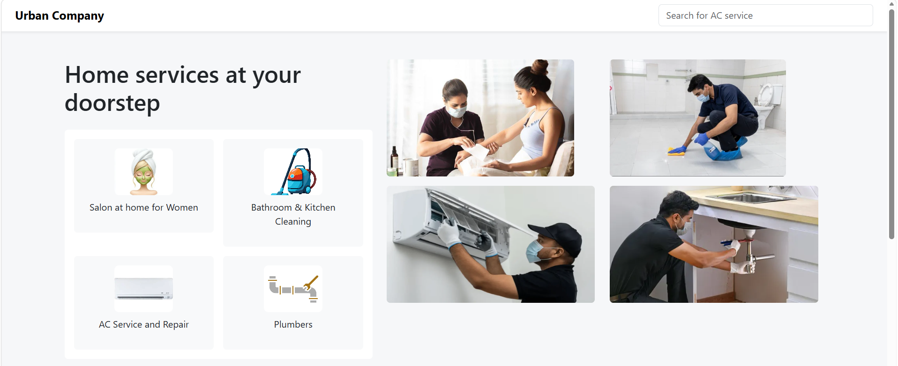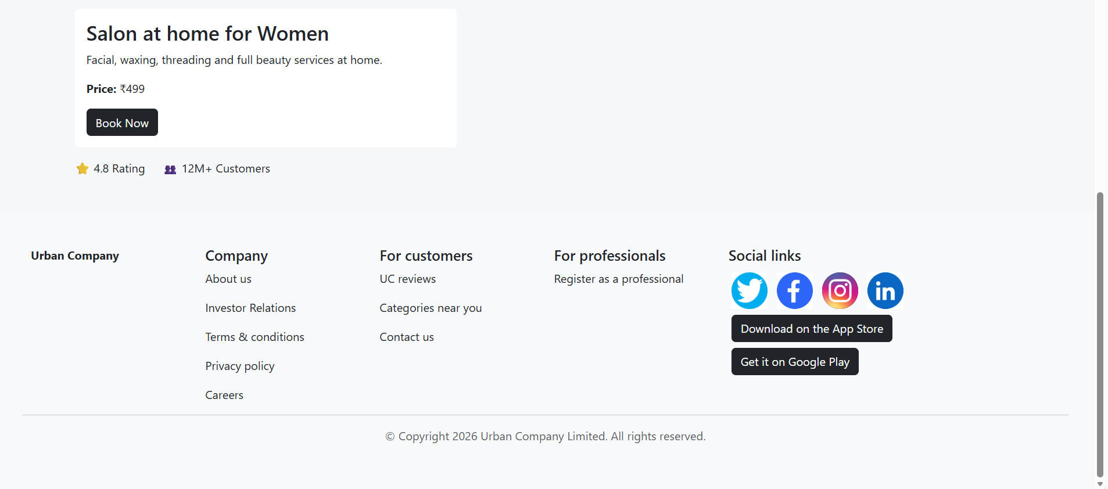
EXPLANATION OF THE TAGS :
HTML Tags
- <html> → Root element that contains the entire webpage.
- <head> → Contains metadata, title, styles, and external links.
- <title> → Sets the browser tab name.
- <link> → Links external CSS (Bootstrap here).
- <style> → Internal CSS styling for the page.
- <body> → Holds all visible webpage content.
- <nav> → Defines the navigation bar section.
- <span> → Inline container used for styling text (brand name).
- <input> → Creates a text input field (search box).
- <div> → Generic container used for layout and grouping elements.
- <h1> → Main heading text.
- <h3> → Subheading inside service details.
- <h5> → Smaller section headings in footer.
- <p> → Paragraph text.
- <img> → Displays images on the webpage.
- <button> → Clickable button element.
- <strong> → Makes text bold with importance.
- <hr> → Horizontal line separator.
- <script> → Contains JavaScript code.
Bootstrap Classes (used inside tags)
- navbar → Creates a responsive navigation bar.
- container → Centers and adds padding to content.
- row → Defines a horizontal row for grid layout.
- col-md-* → Defines responsive columns.
- bg-white / bg-light → Background colors.
- p-* / m-* → Padding and margin spacing utilities.
- rounded → Adds rounded corners.
- shadow-sm → Adds small shadow.
- btn btn-dark → Styles buttons.
- text-center / text-muted → Text alignment and color.
- img-fluid → Makes images responsive.
- fw-bold → Makes text bold.
CSS Classes
- .card-hover → Adds hover effect (zoom + color change).
- .details → Initially hides service details section.
- .service-img → Styles service icons (size & shape).
- .main-img → Styles main images.
- .social-btn → Circular social media buttons.
JavaScript
- const services → Stores service data (title, description, price).
- let selectedService → Keeps track of selected service.
- function showService() → Displays selected service details dynamically.
- document.getElementById() → Selects HTML elements by ID.
- .innerText → Updates text content inside elements.
- .style.display → Controls visibility of elements.
- function bookNow() → Shows booking confirmation alert.
- alert() → Displays popup message.

